Welding Engineering is a very complex engineering discipline that requires a proficiency penetrating well beyond the bounds of its simple description.
Many non-engineering personnel can be forgiven for inferring that all personnel identified as ‘welding engineers’ have the necessary skills needed to provide solutions associated with ALL joining methods, even if they are solely involved with metallic materials. This is a very precarious situation for such personnel to find themselves faced with, especially as we move into an era where joining engineering required by the energy and transportation sectors will become a critical discipline for success.
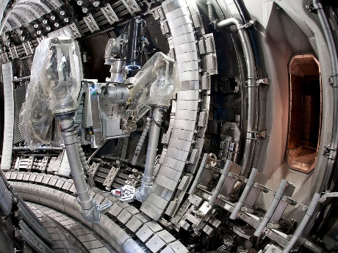
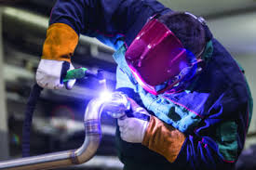
It has been well established that welding and welding engineering, like so many other engineering disciplines, hashad to continuously evolve in embracing new technology and methods of manufacturing, to not only expand market opportunities, but to simply maintain a competitive status if they wish to stay in business.
Although the profession has, for many years, been perceived to be a grim, fume-filled, uncomfortable environment to work within, the demand to deliver improved structural performance, on-time and at a reduced cost is now forcing a significant change.Students and practitioners who pursue the industry recognised welding engineering diplomas (EWS/IWS, EWT/IWT and EWE/IWE) will be provided with the basic tools to support industry and underpin their existing experience, however, this presentation willprovide an insight into those manufacturing engineering challenges the energy and transportation sector face to achieve the net-zero target, and provoke thoughts as to what are the wider skills sets required for existing ‘welding engineers’to have in their toolbox in orderto overcome these hurdles.
As a flavour of what to expect, this presentation will provide an insight into whythe followingdisciplines will need to integrate into a welding engineer’s skills set for the future:
  - Advanced materials and processing methods
  - Design, inspection and joiningtechnologies
  - Life-cycle analysis
  - Sustainability
  - Digitalisation
  - Modularisation
  - Integrated systems engineering principles
The presenter will also share his knowledge of advanced joining and materials engineering as part of his previous role in leading the Nuclear AMRC’s advanced research programmes, along with his current role in leading the strategic joining research being undertaken within the University of Sheffield and the high-value manufacturing catapult. Furthermore,his work involved with the research support office, part of the Nuclear Waste Services is focused on the geological disposal facility (GDF) andstretches the imagination of what will be needed for potentially the UK’s largest infrastructural project for the 21st and 22ndCenturies.
Presentation to be given by Dr Steve Jones CEng, FWeldI
Professor of Welding, Brazing and Bonding technologies – University of Sheffield
The High-Value Manufacturing Catapult Chief Engineer for Joining
Nuclear Waste Services – Research Support Office’s GDF Advanced Manufacturing Discipline Lead

