EASTERN COUNTIES BRANCH

Bristol Scout 1264: Rebuilding Grandad's Aircraft
Wednesday 10th November 6.30pm, Online (Zoom)
An Illustrated talk by David Bremner

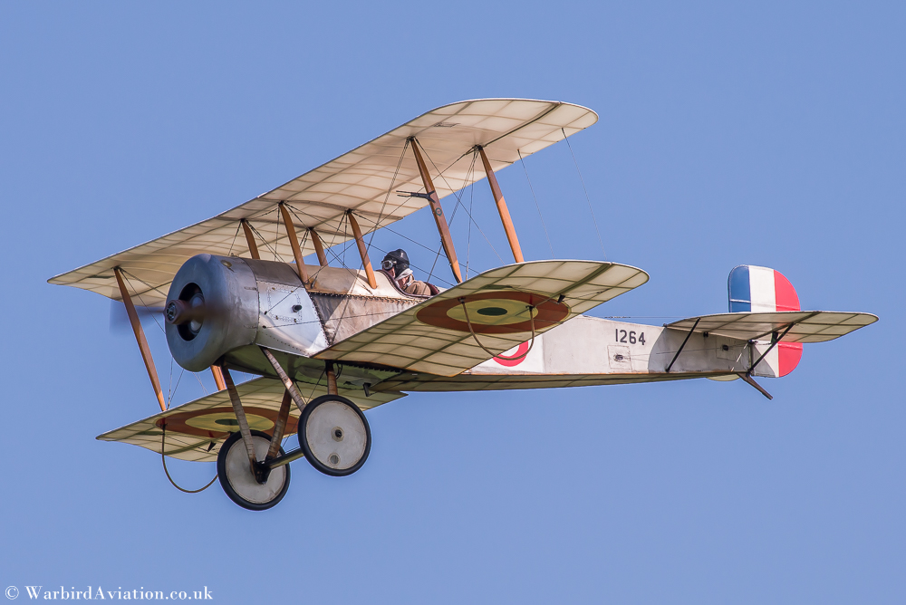
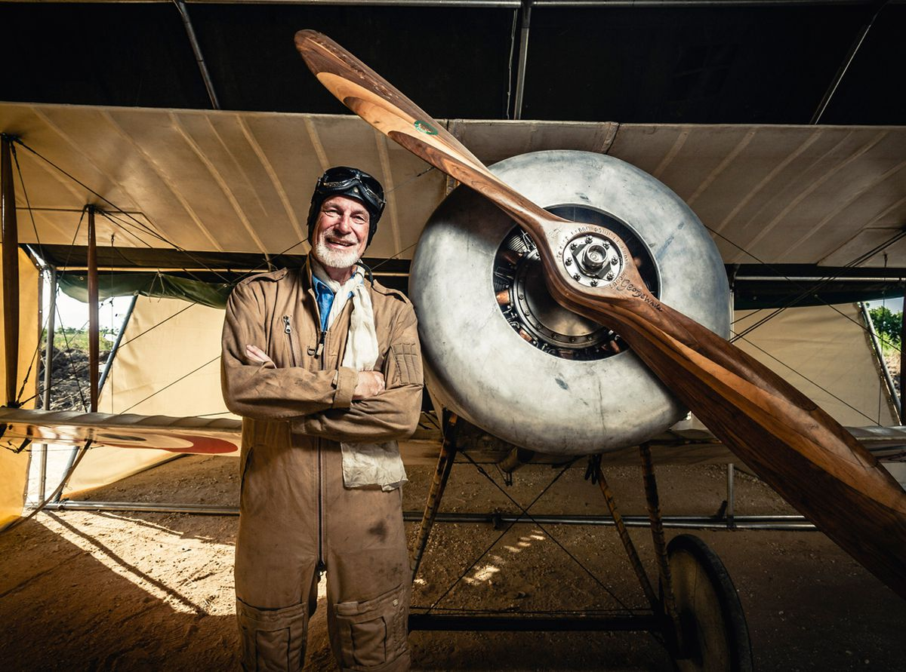

Speaker Biography: David Bremner started flying hang gliders in the 1970s, progressing to microlights and light aircraft. He is an inspector for both UK sport aircraft associations and has flown most of the current microlight models on the market. To fund this, he is a part time quality systems auditor specialising in pressure equipment.

In 1913, Frank Barnwell designed the Bristol Scout, which was the fastest and most manoeuvrable warplane for the first eighteen months of the First World War, and became the prototype single-seat fighter from which all later fighters were derived. In 1916, Flt Sub Lt Francis (Bunnie) D. H. Bremner RNAS flew Bristol Scouts for No. 2 Wing in the eastern Mediterranean. In 1983, his grandson David discovered three aircraft parts from Scout no. 1264 in his late grandfather's workshop and twenty years later he, together with his friend Theo Willford, researched the possibility of rebuilding her from these three parts.
This Talk covers the challenges faced by David, his brother Rick and Theo, in recreating 1264 and getting her airworthy.

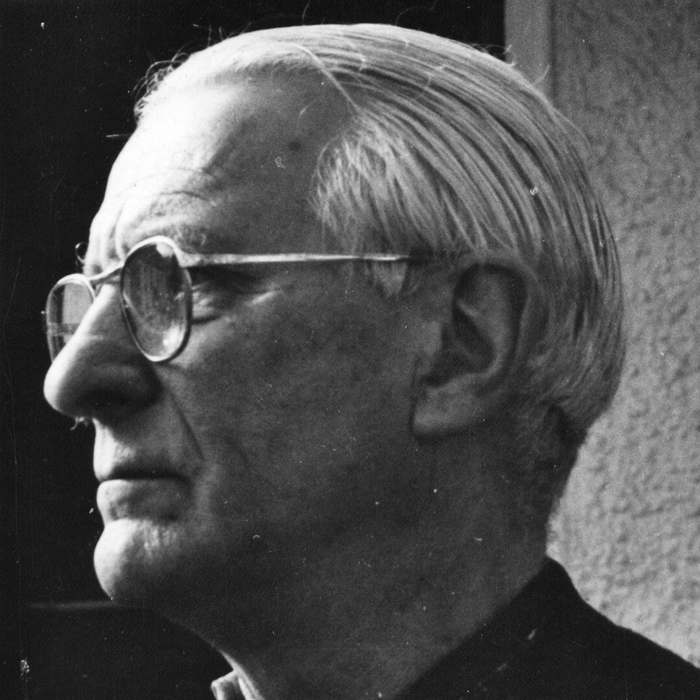

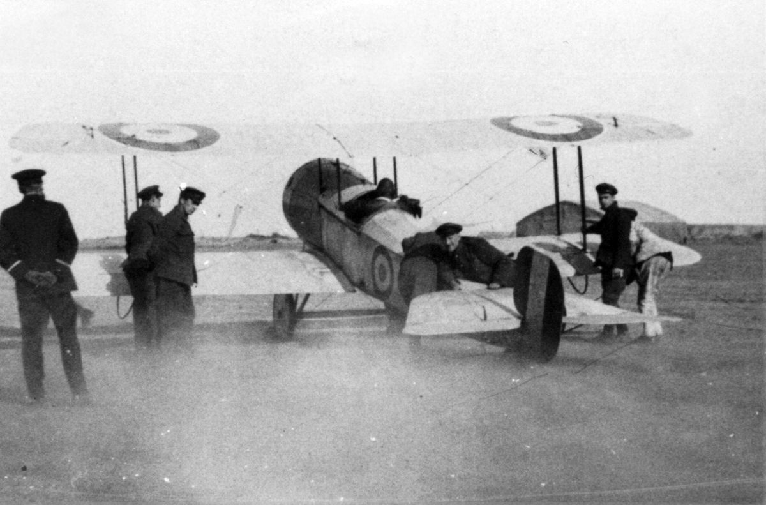

Bunnie Bremner running up the engine of Bristol Scout 1264 Bunnie Bremner
prior to take-off on the Greek island of Imbros

