Eastern Counties Branch

Guided Tour of the Denver Sluice Complex
Where Sluice Road meets Ten Mile Bank, Norfolk PE38 0AZ
with Dan Pollard, Flood and Coastal Risk Management Officer /
Complex Superintendent for the Environment Agency
Saturday 18th June 10.00am

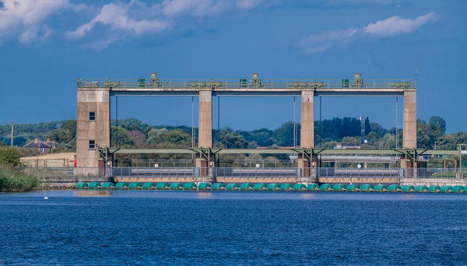

Denver is located just south west of Downham Market and is probably the largest sluice complex anywhere in the country. From the 1600s, when the original sluice was constructed, the key purpose has been to protect the people of the Fens, their property and low-lying land from flooding. Today, with the current system of sluices and structures at the Environment Agency still focusses on flood protection. However, over the years, additional responsibilities have been added, at the heart of which is the Great Ouse River system.

This means managing a number of converging major drainage systems as well as tidal waters, all coming together at Denver. These include the Bedford Ouse, the Ely Ouse, the Old Bedford River, the Ouse Washes Reservoir, the Tidal River, the Cut-off Channel and the Flood Relief Channel. Add to this, such variables as rainfall, river flows, wind speed/direction and tidal variations you can see why it is called the Denver Complex!

