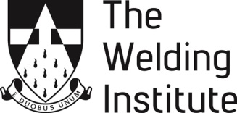 

**ARMOURERS AND BRASIERS AWARDS 2020**

**NSIRC TRAVEL AWARDS**

Armourers and Brasiers Gauntlet Trust are offering travel grants of £500 - £1000 to assist towards travel and subsistence.

The aim of the grant is to allow post graduate students, undertaking studies in materials joining and structural integrity, to attend an international conference relevant to their studies. Attendance at the conference should endow the student with a beneficial academic and networking experience.

Recipients of a travel grant will be required to submit a report (Minimum of 1500 words) or give a short presentation highlighting the learning outcomes gained from the activity for which they have utilised the award.

**How to apply:**

Applicants are invited to submit the details and estimated costs of the conference, highlighting its relevance to their studies.

Applications must be supported in writing by Head of Department or supervisor.

Applications should be emailed to: [twiawards@twi.co.uk](mailto:twiawards@twi.co.uk)

Or posted to: The Membership Office, TWI Ltd, Granta Park, CAMBRIDGE, CB21 6AL

**Closing Date**: **14th February 2020**

**\*\*\*Please note that unless all application documents are received by the application deadline, your application will be considered incomplete and will not be submitted to the judging panel\*\*\***